Threads: Threads are fundamental unit of execution that allows program to perform tasks concurrently.
-> They enable developers to create responsive applications, utilize multi-core processors efficiently and improve overall application performance.

Processes Vs Thread:
Characteristic | Process | Thread
Definition | An independent program with its own memory space. | A lightweight unit of execution within a process
Memory | Separate memory space. | Shared memory within the same process.
Resource Allocation | Fully independent resource allocation. | Shared memory with other threads in the same process
Overhead | High (creating a new process is resource intensive). | Low (threads are lightweight and quick to create).
Communication | Inter-process requires complete mechanisms | Easy communication through shared memory
Isolation | High isolation between processes. | Low isolation (threads can directly affect each other)
Switching cost | Expensive context switching. | Relatively inexpensive context switching.
Failure Impact | One process crash doesn’t typically affect others. | Thread failure can potentially crash the entire process.

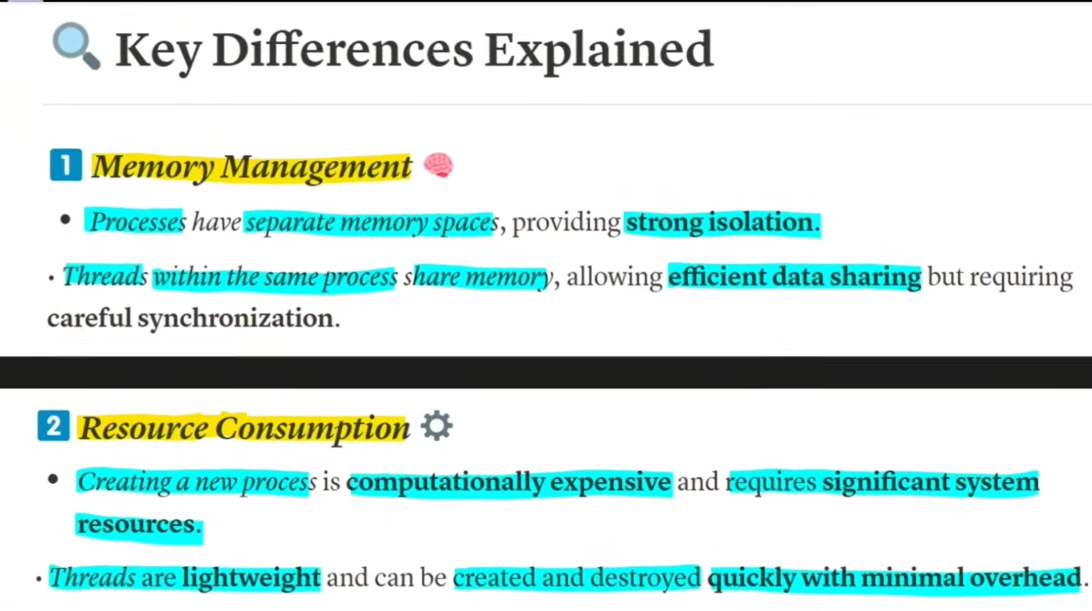

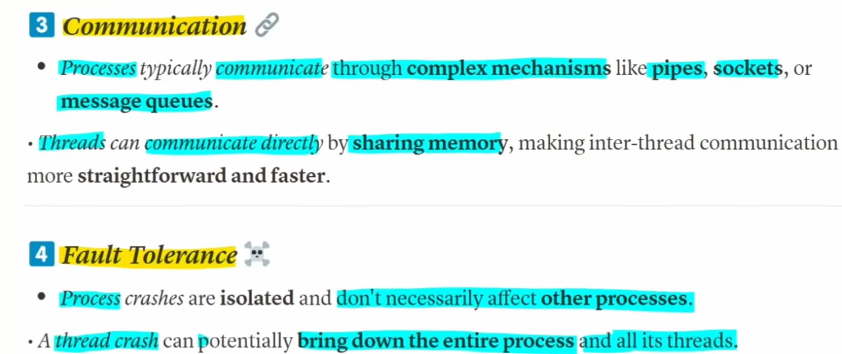

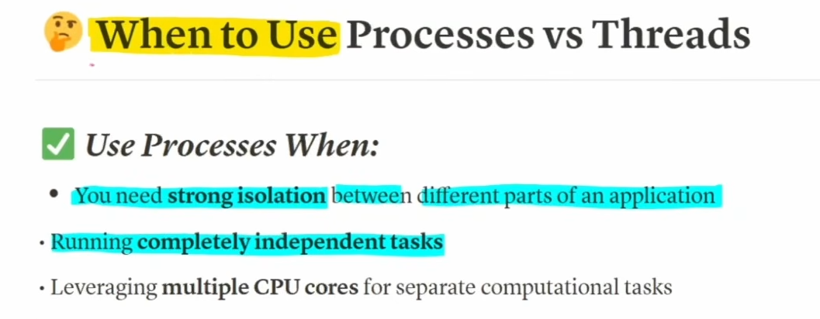
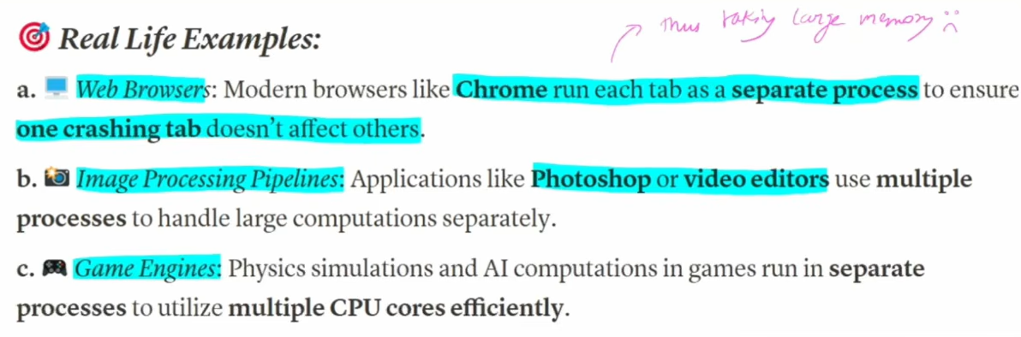

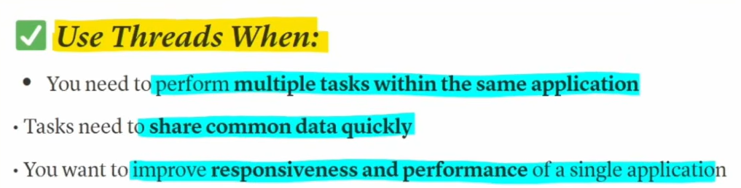



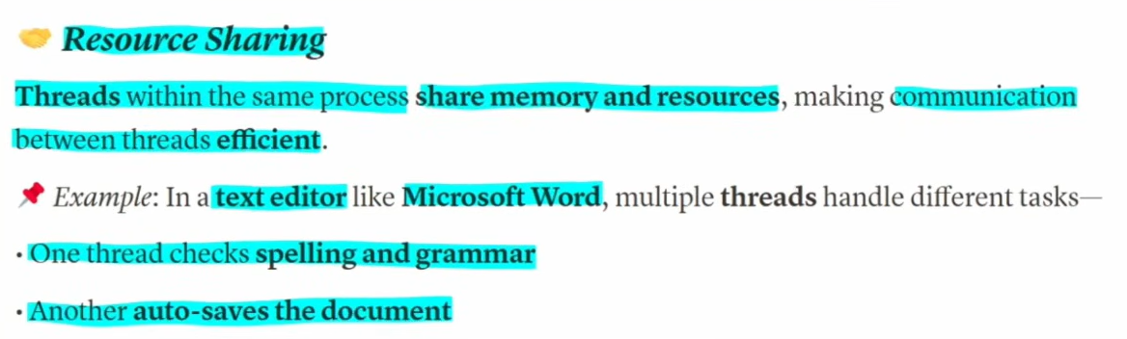


Thread Creation:
- Extending Thread Class (By overriding run() method):
- Simpler to implement for beginners.
- Direct access to Thread methods.
- Limits inheritance (Java doesn’t support multiple inheritance).
- Each task requires a new Thread instance.
- Implementing Runnable Interface:
- Better object-oriented design.
- Allows classes to extend other classes.
- Same Runnable instance can be shared across multiple threads
- More flexible for executer framework.
- Slightly more code to run.

Callable

